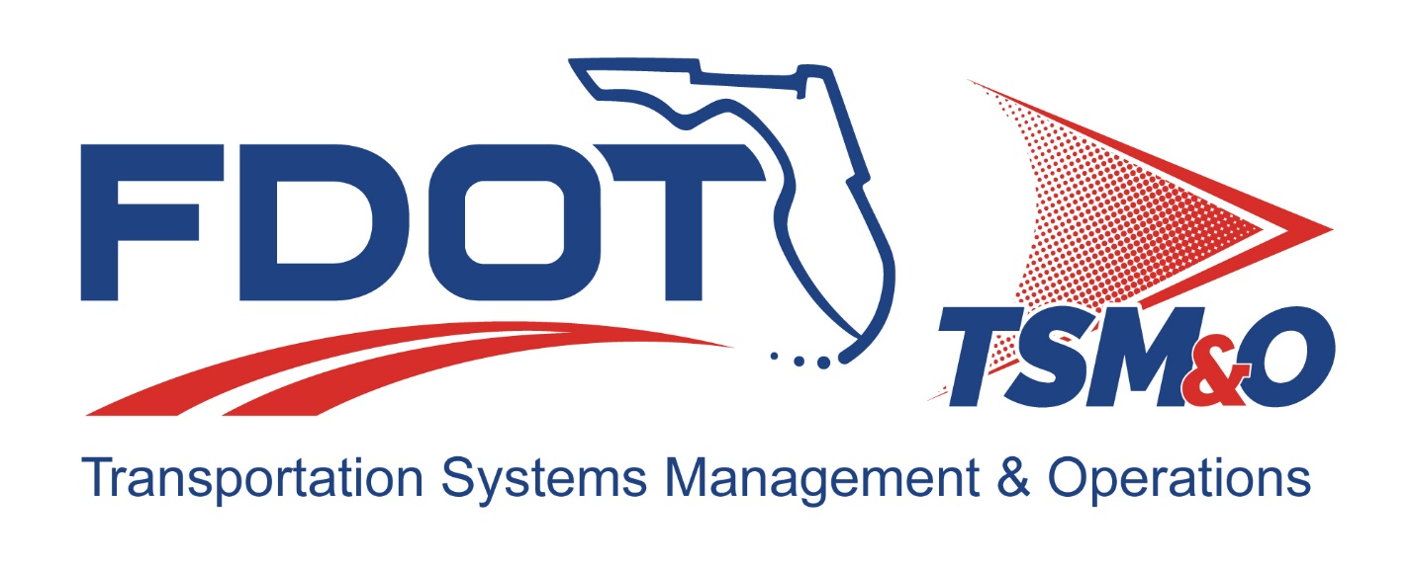

**Concept of Operations for: *SunGuide® Software and Regional Integrated Corridor Management System Integration***

**Version: *1.0***

**Approval date: *TBD***

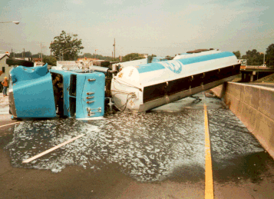

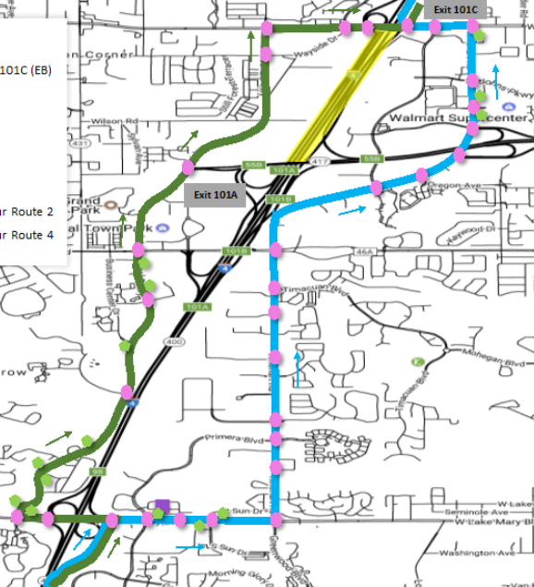

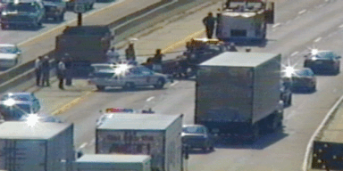

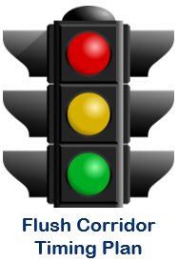

|  |  |  |
| --- | --- | --- |
| **DOCUMENT CONTROL PANEL** | | |
| File Name: |  | |
| File Location: |  | |
| Version Number: | 1.0 | |
| **Name** | | **Date** |
| Created By: | Clay Packard, VHB on behalf of FDOT D5 | 11/9/2017 |
|  |  |
| Reviewed By: | Derek Vollmer, FDOT CO | 12/1/2017 |
| Derek Vollmer, FDOT CO | 12/21/2017 |
| Derek Vollmer, FDOT CO | 12/28/2017 |
| Craig Carnes, Metric on behalf of FDOT D2 | 1/8/2018 |
| Ryan Christ, Metric on behalf of FDOT D2 | 1/8/2018 |
| Vinny Corazza, FDOT D7 | 1/12/2018 |
|  |  |
|  |  |
|  |  |
| Modified By: | Clay Packard, VHB | 11/9/2017 |
| Clay Packard, VHB | 12/12/2017 |
| Clay Packard, VHB | 12/22/2017 |
| Clay Packard, VHB | 1/18/2018 |
|  |  |
|  |  |
|  |  |
|  |  |
|  |  |
|  |  |
| Approved By: |  |  |

Table of Contents

1. Overview 6

1.1 Document Overview 6

1.2 System Overview 6

2. Referenced Documentation 7

3. Current System Situation 8

3.1 Background, Objectives, and Scope 8

3.2 User Profiles 11

3.3 Support Environment 12

4. Justification and Nature of the Changes 12

4.1 Justification of Changes 12

4.1.1 Justification for ICMS 12

4.1.2 Justification for Using SunGuide Software 12

4.2 Description of the Desired Changes 13

4.3 Assumptions and Constraints 14

4.4 Risks 14

5. Concepts for the Proposed System 14

5.1 Description of the Proposed System 14

5.1.1 ICM Event Detection 15

5.1.2 Diversion Route Recommendation 15

5.1.3 ICMS Operator Review 17

5.1.4 Agency Approval 19

5.1.5 ICMS Sends Response Plan to SunGuide 19

5.1.6 SunGuide Operator Alert 20

5.1.7 SunGuide Event Response Plan 20

5.1.8 Activate Flush Route Timing Plans 22

5.1.9 Event Life-Cycle 22

5.1.10 Other Related Operations and Features 23

5.1.10.1 Performance Monitoring 23

5.2 System Support 24

5.3 Support Environment 24

6. Operational Scenario 24

7. Summary of Impacts 25

8. Notes 26

8.1 Deferred Items 26

List of Figures

Figure 1: SunGuide GUI – Traffic Signal Controller Icons 9

Figure 2: SunGuide GUI – Activate Timing Plan Dialog 10

Figure 3a: SunGuide GUI – Route Selection List 10

Figure 3b: SunGuide GUI – Severity Selection List 11

Figure 4: SunGuide GUI – Signal Route Configuration 11

Figure 5: ICMS Diversion Route 15

Figure 6: SunGuide System Response 15

Figure 7: Example ICMS Diversion Route Response Plan Route Map 16

Figure 8: ICMS GUI – Diversion Route Response Plan Notification Banner 17

Figure 9: ICMS GUI – Corridor Response Plan Details 18

Figure 10: ICMS GUI – Flush Plan Set Details 18

Figure 11: ICMS GUI – Response Plan Approval Status 19

Figure 12: SunGuide GUI – SunGuide Response Plan Dialog 21

**List of Acronyms and Abbreviations**

API Application Program Interface

ATMS Advanced Traffic Management System

C2C Center to Center

ConOps Concept of Operations

CV Connected Vehicle

DMS Dynamic Message Sign

EM Event Management

FDOT Florida Department of Transportation

HAR Highway Advisory Messages

MOE Measures of Effectiveness

ICMS Integrated Corridor Management System

IDS Incident Detection Subsystem

ITS Intelligent Transportation Systems

RTMC Regional Transportation Management Center

TIM Traveler Information Messages

TERL Traffic Engineering Research Lab

TMC Traffic Management Center

TSMO Transportation Systems Management and Operations

TSS Traffic Sensor Subsystem

TVT Travel Time

# Overview

## Document Overview

This Concept of Operations (ConOps) document describes how the SunGuide® software will integrate with the Regional Integrated Corridor Management System (R-ICMS). This integration will impact SunGuide software user operations with the Incident Detection Subsystem (IDS), the Event Management (EM) subsystem, and the response plan management functionality within EM. The SunGuide software will also need to interface with the traffic signal controller’s advanced traffic management system (ATMS) software to produce the desired effect on the transportation system, which includes selecting alternative traffic signal timing plans to support a diversion route.

The intended audience of this document includes the stakeholders of the R-ICMS and SunGuide software. These stakeholders may include sponsors who may benefit from this system, engineers and technologists who may be needed to support this desired operation, and related engineering staff who seek an understanding of FDOT goals when designing the new and modified functionality and attributes of the SunGuide software and the R-ICMS. Stakeholders for the R-ICMS can be found in the R-ICMS concept of operations document, which can be found at the website noted under Section 2 of this document. SunGuide stakeholders affected by the changes needed for SunGuide to integrate with and support the R-ICMS include the following:

* FDOT District 5 are the primary users of the enhancement, at least initially, and are providing most of the SunGuide enhancement’s system operational needs based on how they intend on operating the R-ICMS and SunGuide software for their operations.
* FDOT Central Office ensures programmatic alignment of statewide systems and software architecture. They also manage the modifications to and the support of the SunGuide software.
* The Traffic Engineering and Research Laboratory (TERL) is responsible for testing the ITS traffic control devices and the SunGuide software. The TERL should be informed of changes to the SunGuide software and provided with developer support and device support in order to conduct the needed testing.
* Other Districts in FDOT may consider using the enhancement in the future and have input, and will also need to ensure any proposed changes to the SunGuide software do not adversely impact their own operations.
* Traffic Signal Controller ATMS central software manufactures need to modify their signal ATMS software to provide the API needed by SunGuide to obtain information and issue commands to invoke route response plans. The coordination and modification could take time and funding, and thus needs to be started early.

## System Overview

The SunGuide software is an advanced traffic management system (ATMS) software that is used at all regional transportation management centers (RTMCs) within Florida. SunGuide software offers a comprehensive set of tools to the traffic management centers (TMCs) including Intelligent Transportation Systems (ITS) device management, incident detection, event management, and response plan activation. More information and documentation about SunGuide software can be found here: <http://sunguidesoftware.com/about-hub>

The Regional Integrated Corridor Management System (R-ICMS) monitors traffic conditions and generates diversion route response plans. These response plans provide support for diverting traffic around an incident. These diversion route response plans may include the following response plan items:

* Selection and activation of alternative signal timing plans that are already existing and stored in the signal controller
* Dynamic message sign (DMS) messages to provide information about available diversion routes
* Ramp metering rate change
* Hard shoulder running activation
* Suggestions to manually contact other partners to respond to the incident

The response plans are simulated in a real-time simulation system to ensure they are predicted to produce an improvement in the transportation system over the predicted transportation network performance if no response is invoked. Once vetted by simulation and prediction, diversion route response plans are provided to local agencies who have jurisdiction over the infrastructure to be affected by the response plan for their review and approval. Once approved, they are sent to the SunGuide software to be incorporated into the response plan for a SunGuide event and activated.

# Referenced Documentation

SunGuide software documents can be found at the project website at the following link:  
<http://sunguidesoftware.com/document-library> or by requested from FDOT Central Office:

Derek Vollmer, [derek.vollmer@dot.state.fl.us](mailto:derek.vollmer@dot.state.fl.us)

* *ATMS.now C2C Implementations Rev 1.1*
* *Signals in SunGuide Concept of Operations*
* *SunGuide Operator Training Master Slides - R7.0*

Documentation for the Regional Integrated Corridor Management System (R-ICMS) includes:

* + Exhibit A - Scope of Services for Central Florida Regional Integrated Corridor Management System
  + Exhibit C - System Requirements for Central Florida Regional Integrated Corridor Management System

These 2 exhibits are located at the following link:  
<https://www.governmentcontracts.us/government-contracts/opportunity-details/ADP14872904370000469.htm>

Additional documents of interest for the R-ICMS are available at the following link, <http://www.cflsmartroads.com/projects/ICM.html>, and include the following:

* + [FDOT Production Big Data Platform - Draft](http://cflsmartroads.com/projects/design/tsp/Regional_integrated_corridor_mgmt/FDOT%20Production%20Big%20Data%20Platform.pdf)
  + [Concept of Operations](http://cflsmartroads.com/projects/design/tsp/Regional_integrated_corridor_mgmt/DSS%20and%20ATMS%20Software%20Operational%20Concept%20-%20final%20-%20FDOT.pdf)
  + [Action Plan - Final](http://cflsmartroads.com/projects/design/tsp/Regional_integrated_corridor_mgmt/ActionPlan_FINAL.pdf)
  + [TSM&O Data Fusion Concept Architecture - Draft](http://cflsmartroads.com/projects/design/tsp/Regional_integrated_corridor_mgmt/TSMO_DataFusion_Concept_Architecture_Draft_V2.vsdx)
  + [TSM&O IT Software & Applications - Draft](http://cflsmartroads.com/projects/design/tsp/Regional_integrated_corridor_mgmt/FDOT%20D5%20TSM&O%20IT%20Software%20&%20Applications%20-%20DRAFT.pdf)
  + Data Interfaces
    - [Data Dictionary Sample Documents](http://cflsmartroads.com/projects/design/tsp/Regional_integrated_corridor_mgmt/Data_Interfaces/Data%20Dictionary%20Sample%20Documents/Sample_Docs.zip) (.zip)
  + Detour Maps
    - [Orange County Detour Maps](http://cflsmartroads.com/projects/design/tsp/Regional_integrated_corridor_mgmt/Detour_Maps/Orange%20Co.%20Detour%20Maps.pdf)
    - [Osceola County Detour Maps](http://cflsmartroads.com/projects/design/tsp/Regional_integrated_corridor_mgmt/Detour_Maps/Osceola%20Co.%20Detour%20Maps.pdf)
    - [Seminole County Detour Maps](http://cflsmartroads.com/projects/design/tsp/Regional_integrated_corridor_mgmt/Detour_Maps/Seminole%20Co.%20Detour%20Maps.pdf)
  + Related Presentations
    - [Big Data & Decision Support for an ICM System](http://cflsmartroads.com/projects/design/docs/Big_Data_Decision_Support.PPTX)
    - [FY 2018 CAP Presentation](http://cflsmartroads.com/projects/design/docs/FY%202018%20CAP%20Presentation%20Traffic%20Ops.pptx)

# Current System Situation

## Background, Objectives, and Scope

The SunGuide Software was originally built for freeway operations, and its role is to manage devices, manage events, and produce reports. SunGuide has recently been enhanced to support the diversion route using the ATMS.now system to activate a pre-configured route timing plan during an incident to implement a diversion route around a freeway incident. This functionality includes the interface between SunGuide and the ATMS.now central traffic signal controller interface, where SunGuide can receive traffic signal controller status and activate a different route timing plan. Additionally, SunGuide will have a route timing plan as a type of a response plan element, or item, that can be added to a SunGuide EM event response plan by the SunGuide operator.

**Note:** the term timing plan is somewhat overloaded in various documentation, and care has been taken in this document to use the term route timing plan and traffic signal controller timing plan to differentiate between the two.

* A traffic signal controller timing plan is a pattern of intersection movement phase changes including splits, offsets, and other implementation details that the traffic signal controller uses to control phase changes at an intersection.
* A route timing plan refers to a traffic signal controller timing plan on a set of traffic signal controllers defined within the traffic signal ATMS central software. This allows a single action at a high level to change the traffic signal controller timing plan for multiple traffic signal controllers.

**Another Note:** the term *response plan* is also somewhat overloaded in various documentation, and care has been taken in this document to use the term *SunGuide EM event response plan* and *R-ICMS response plan* to differentiate between the two.

* A *SunGuide EM event response plan* is a response plan in the SunGuide system that is associated to a SunGuide EM event. This response plan contains response plan elements, or items, that that SunGuide operator can review and modify. This SunGuide EM event response plan can be activated to control SunGuide to control the various ITS devices to be changed including sending messages and changing traffic signal timing plans by interfacing with the traffic signal controller ATMS central software.
* An *R-ICMS response plan* refers to the diversion route response plan recommendation created by R-ICMS based on the internal rules and predictive analytics and approval coordination. This is sent to SunGuide upon approval by the R-ICMS operator and agencies where SunGuide software uses it to incorporate the contents into a SunGuide EM event response plan.

The Signals in SunGuide operation is detailed in the *Signals in SunGuide Concept of Operations document*, and the interface to the Trafficware system is detailed in the *ATMS.now C2C Implementations Rev 1.1* document. This operation is summarized below.

SunGuide shows the status of traffic signals on the map using the icons depicted in Figure 2. This status is what was reported by the ATMS.now central software, and only includes the status of the signal. These icons appear on the operator map, indicating the status of the signal, where there are signals reported by ATMS.now. Figure 1 shows a snippet of the icon configuration control where you can see what the icon looks like and can enable or disable the entire layer of signal icons shown on the map and can even change the status color of the icon.

C:\Documents\Projects\SunGuide Training\Master Slides\Screen Shots\Screan Shots R7.0\TCS\icons.png

Figure 1: SunGuide GUI – Traffic Signal Controller Icons

SunGuide also lists the route timing plans available in the traffic signal ATMS and configured in the SunGuide software. This list is displayed to the SunGuide software operator at the top of the Activate Timing Plan dialog shown in Figure 2. When the user selects a route timing plan, the included traffic signal controllers are shown in the bottom list. The user has the ability to activate the route timing plan from this Activate Timing Plan dialog without using a SunGuide EM event response plan by selecting a route timing plan and clicking activate.

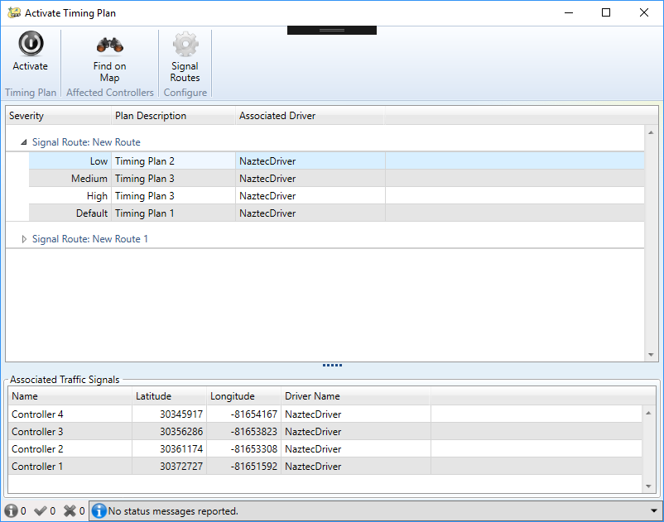

Figure 2: SunGuide GUI – Activate Timing Plan Dialog

When using the SunGuide EM event response plan to activate the corridor timing plan, the user can select an associated route and severity for which a corridor timing plan is needed from the Selection Lists as shown in Figures 3a and Figure 3b. SunGuide will then incorporate the selected route timing plan into the SunGuide EM event response plan.

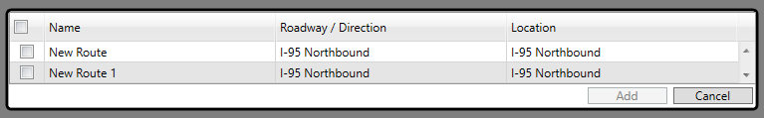

Figure 3a: SunGuide GUI – Route Selection List

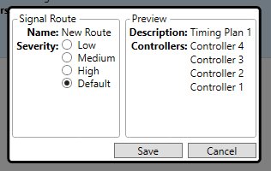

Figure 3b: SunGuide GUI – Severity Selection List

In fact, this association between a corridor timing plan and a route and severity is defined in the Signal Route Configuration Dialog shown in Figure 4.

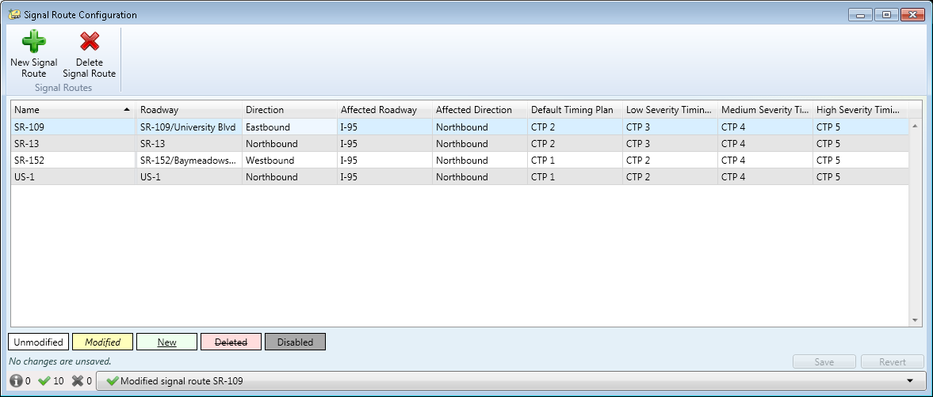

Figure 4: SunGuide GUI – Signal Route Configuration

To support this operation, ATMS.now currently allows the following features through their SunGuide interface protocol:

1. get controller status including the current timing plan identifier,
2. get route timing plans which would include the timing plan identifier and a list of controllers that would be affected, and
3. activate a route timing plan

## User Profiles

The following user profiles are involved with the existing operations:

1. ***Traffic Management Center (TMC) SunGuide Operator***: This person is responsible for managing ITS devices and events, and for operating the SunGuide software.
2. ***Traffic Management Center (TMC) Manager:*** This person is responsible for overseeing the systems and managing the operations staff at the TMC. This person is not a professional engineer.
3. ***Traffic Management Center (TMC) Corridor Manager***: This person is responsible for managing the corridor operations, is physically located at the TMC, and is operating the R-ICMS user interface software. This person is typically a SunGuide software operator. There will typically be one TMC corridor manager per county, with Orange county having one TMC corridor per distinct ATMS system.
4. ***Traffic Management Center (TMC) Arterial Manager:*** This person is a traffic engineer with a professional engineering license. This person responsible for managing the arterial roadway and can make timing plan adjustments and sign and seal the adjustments.
5. ***Maintaining Agency Traffic Engineer***: This person is a traffic engineer with a professional engineering license. This person is responsible for maintaining the traffic signal systems, including the traffic signal timing plans. This person will review diversion route recommendations and approve them if they are acceptable in their engineering judgement.

## Support Environment

The SunGuide software is hosted by equipment residing in the regional transportation management center (RTMC). The SunGuide software will continue to be supported under contract through FDOT central office, including a 1 hour response time for failures.

# Justification and Nature of the Changes

## Justification of Changes

### Justification for R-ICMS

By incorporating an R-ICMS into the TSMO operations for supporting diversion routes, expected benefits are as follows:

* Predict the measures of effectiveness (MOE) 30 minutes into the future so that the expected benefit to the roadway network is quantified prior to making a change, and so that changes are compared with alternative changes and with the no-change scenario.
* Determine which diversion route response plan is predicted to achieve the highest MOE
* Determine if not using a diversion route response plan is preferable due to lack of MOE
* Determine when a diversion route response plan is no longer needed and no longer provides a benefit

### Justification for Using SunGuide Software

R-ICMS will perform the heavy lifting to determine an R-ICMS response plan containing a diversion route with the benefits above. However, the SunGuide EM response plan needs to be managed and activated, and traffic signal controller systems need to be affected to implement the R-ICMS response plan. SunGuide is the system that is desired to incorporate the R-ICMS response plan elements into the SunGuide EM response plan, provide the event management of the SunGuide EM event, and allow for the activation of the R-ICMS response plan elements as part of a SunGuide EM event response plan for the following reasons:

* SunGuide is already the Department’s established system with which to manage traffic events and response plans.
  + Without SunGuide integration, R-ICMS would have to redundantly provide the ability to manage events and activate response plans. This would require operators to perform overlapping functions on separate systems, which is inefficient.
* SunGuide is already the Department’s established system with which to manage and integrate with traffic control devices and systems. Without SunGuide integration, R-ICMS would have to directly integrate with traffic control systems for signal controller timing plan changes and then with SunGuide for DMS and other response plan item control. This would require R-ICMS to control some systems and still interface with SunGuide software to control others. This would be cumbersome and inefficient for operators to operate multiple systems.
* The more efficient way that is the least complex for R-ICMS and SunGuide software operators is to amend existing SunGuide event management and response plans operations to accept R-ICMS response plan element recommendations from R-ICMS.

## Description of the Desired Changes

R-ICMS will be developed by a separate contract. The desired changes for SunGuide are the following modifications:

* Provide an interface for the R-ICMS system to provide a R-ICMS response plan recommendation.
* Process the R-ICMS response plan recommendation. SunGuide will then prompt the operator of the R-ICMS response plan recommendation.
* Interface with the traffic signal central software systems, also called Advanced Traffic Management System (ATMS) (to absolutely be confused with Advanced Transportation Management System, also ATMS), and typically used to refer to systems capable of managing traffic signal controllers. But let not your heart be troubled – the remainder of this document will refer to traffic signal ATMS, or to the SunGuide software for clarity. The interface from the SunGuide software to the traffic signal ATMS needs to include the following capabilities:
  + Retrieve the status information including the route timing plans and the traffic signal controller timing plans available and currently in use. The detailed requirements will be documented in the Traffic Signal ATMS Interface Requirements during the requirements and design phase.
  + The SunGuide traffic signal ATMS interface should be able to integrate with the following products used in the central Florida region:
    - Seimens Tactics used by Orange County,
    - Econolite Centracs used by Osceola and Volusia counties, and
    - Trafficware – engineered by Naztec – used by Brevard and Seminole counties and the City of Orlando.
  + The traffic signal ATMS should be configured as a device like other ITS devices so that a single SunGuide driver can handle multiple traffic signal ATMS deployments. This simplifies the deployment, avoiding non-standard deployment beyond the capability of the SunGuide installation software where there are multiple Windows processes with the same name. This will be useful in District 2 where Jacksonville and Gainesville have separate ATMS.now traffic signal ATMS systems integrated to the single, District SunGuide software deployment. District 5 will have multiple instances of 3 different types of traffic signal ATMS software products to integrated into their single SunGuide software system.
  + Traffic signal ATMS information obtained from the interface as well as the status of any response plan control activity should be able to be retrieved and subscribed to from within databus. This communication channel already exists but may have to be extended to include additional information such as traffic signal controller timing plan definitions.

## Assumptions and Constraints

* Traffic signal controller timing plans must be signed and sealed by a professional traffic engineer; thus, R-ICMS will only select traffic signal controller timing plans from ones available in the traffic signal controller for the R-ICMS response plan recommendation.
* Changes to a traffic signal controller, including selecting different route timing plans or selecting traffic signal controller timing plans, must have been coordinated with the local maintaining agency responsible for operating the traffic signal controller. The coordination will occur in the R-ICMS software.
* Changes to a traffic signal controller should be made no fewer than a configurable number of minutes per agency, with 15 minutes as a default value, after the previous change to that traffic signal controller unless a supervisor overrides this constraint. The need for supervisory approval is also configurable.
* SunGuide software shall be used to integrate and control the traffic signal control equipment through the SunGuide signal control subsystem as consistent with current operations.

## Risks

* Modifications to traffic signal ATMS products require careful coordination with vendors, detailed requirements, and sufficient lead-time for implementation, and thus need to be started early.

# Concepts for the Proposed System

## Description of the Proposed System

R-ICMS and SunGuide work together in sequence to facilitate a diversion route around an incident.

**Steps 1 – 5:** R-ICMS will produce the R-ICMS response plan recommendation containing a diversion route, obtain approvals from local agencies, and send to the SunGuide software, as depicted in Figure 5.

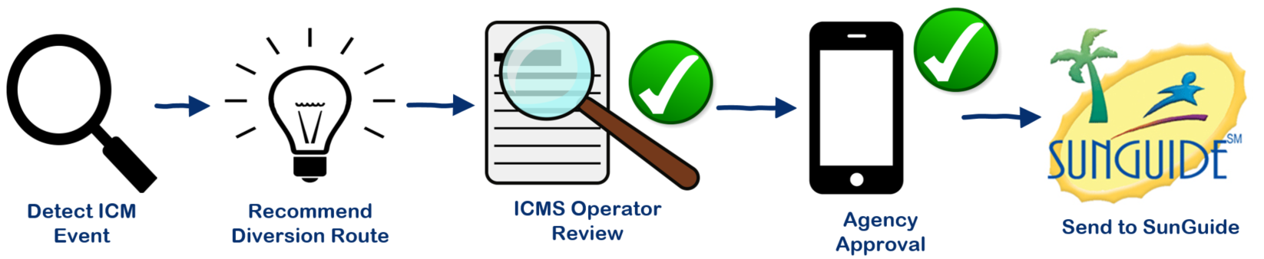

Figure 5: R-ICMS Diversion Route

**Steps 6 – 8:** SunGuide will receive the R-ICMS response plan recommendation, handle event management and response plan activation, and actuate the traffic signal ATMS and other ITS devices as depicted in Figure 6.

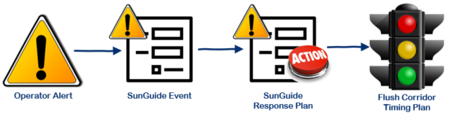

Figure 6: SunGuide System Response

### ICM Event Detection

R-ICMS will monitor real-time data to detect when an ICM event occurs. R-ICMS will connect to the SunGuide databus and other data sources directly to receive real-time information including events, their location, and their severity. R-ICMS will detect an incident based on a SunGuide event, or based on other traffic conditions information indicating the presence of an event. Even after an event is detected and active, R-ICMS will continue to monitor conditions for changes that may warrant a re-evaluation and a change or termination to any diversion routes already in place. Once an event is detected or event conditions are detected to have changed, R-ICMS will internally proceed to the next phase of recommending an R-ICMS response plan for activation, modification, or termination.

### Diversion Route Recommendation

To generate a recommendation, R-ICMS will utilize a rules engine which will use the location and severity of the traffic conditions data or the SunGuide event to produce a set of candidate R-ICMS response plans containing diversion routes and other R-ICMS response plan elements from a library of pre-defined R-ICMS response plan sets pre-engineered for this purpose. R-ICMS will then simulate the transportation network to predict future conditions 30 minutes into the future for each of the R-ICMS response plan set candidates including the *do-nothing* scenario in which no response plan will be applied to the transportation network. The simulations will provide output from which the R-ICMS will calculate measures of effectiveness (MOE) which will then be used to evaluate the R-ICMS response plan candidates. R-ICMS will select a recommended R-ICMS response plan.

The ICM diversion route response plans will contain one or more alternative routes, DMS signs, and other responses. An example showing a route from a response plan is depicted in Figure 7.

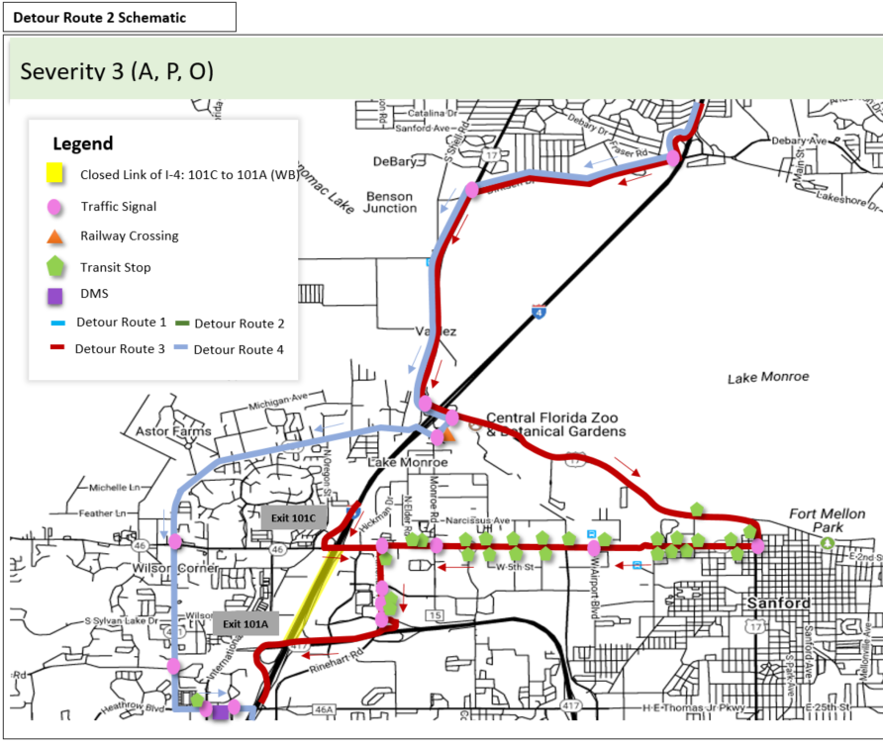

Figure 7: Example R-ICMS Diversion Route Response Plan Route Map

### R-ICMS Operator Review

R-ICMS will go through an approval process with the R-ICMS operator and the maintaining agencies before sending an R-ICMS response plan to the SunGuide software. The first person to review will be the R-ICMS operator. The R-ICMS operator will be notified of a new R-ICMS response plan recommendation with a banner on the R-ICMS home screen as shown in Figure 8.

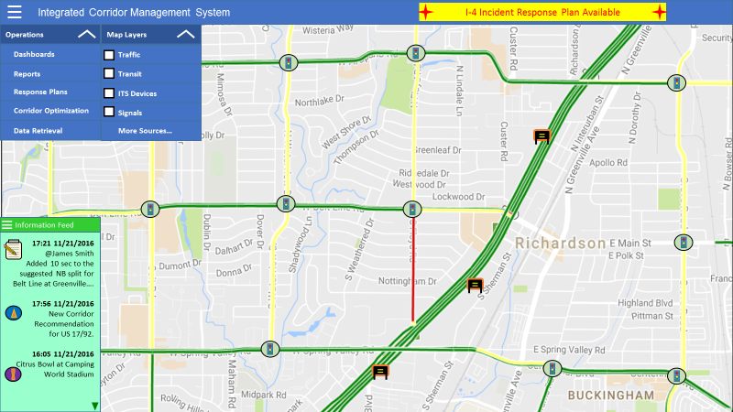

Figure 8: R-ICMS GUI – Diversion Route Response Plan Notification Banner

The R-ICMS operator will click on the notification banner or on another component that will show all R-ICMS response plans with some pertinent information, including the predicted improvements, the agency approval status, and activation status as shown in Figure 9. When a plan is selected from the list, the response plan is shown on the map and the items in the response plan are shown in a second table.

Note: In the design phase of the R-ICMS there will be additional details worked out including how to incorporate the activation status, which could very well reuse the same column in the table as the Agency approval status since the activation status won’t change from its initial state until all agencies approve the plan.

The operator cannot adjust the route timing plans. The operator can adjust other aspects of the response plan. The adjustments are limited to excluding the entire diversion route of signal controller timing plan selection changes. Other adjustments to the response plan include the ability to modify individual DMS messages, connected vehicle (CV) traveler information messages (TIM), highway advisory radio (HAR) messages, and through the standard response plan review and modification part of the operation.

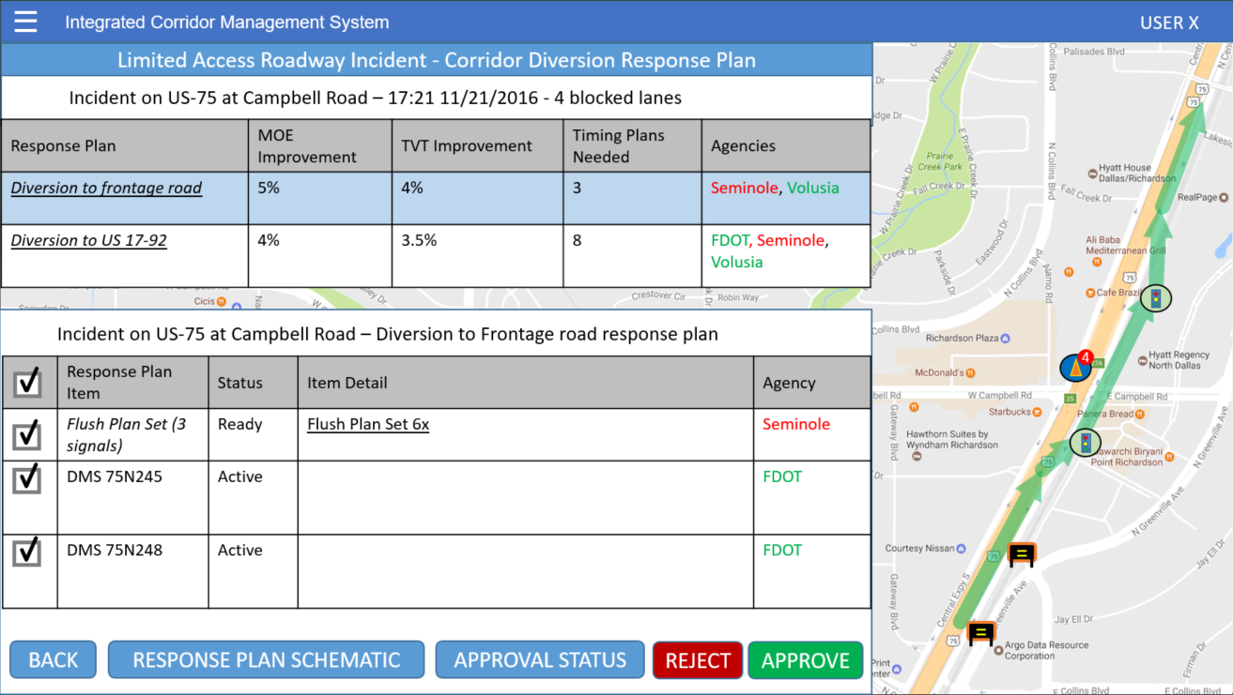

Figure 9: R-ICMS GUI – Corridor Response Plan Details

The R-ICMS operator can click on the Flush Plan Set to reveal the Flush Plan Set Details screen to review additional details about the flush corridor timing plan, including signal controller timing plan details and predicted MOEs as shown in Figure 10. This screen is read-only.

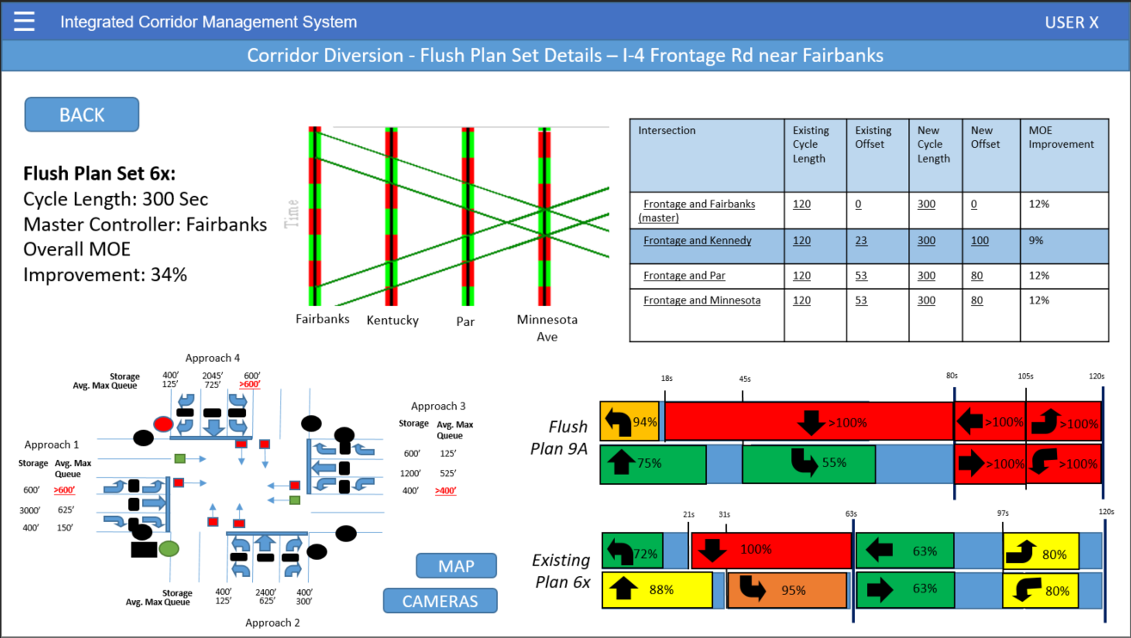

Figure 10: R-ICMS GUI – Flush Plan Set Details

### Agency Approval

After the R-ICMS operator has completed the review and selection of R-ICMS response plan elements, and has approved the plan for agency coordination, the R-ICMS response plan is distributed to each agency according to the approval profile for that agency. The approval profile contains detail on how R-ICMS response plans are approved, including who is the approver and if R-ICMS can automatically approve on behalf of that agency if the approver is not available after a configurable time period, and how this can vary at different times and locations.

The Approval Status screen shows details of the status of obtaining approval from all agencies who have jurisdiction over any affected traffic signal controllers as depicted in Figure 11.

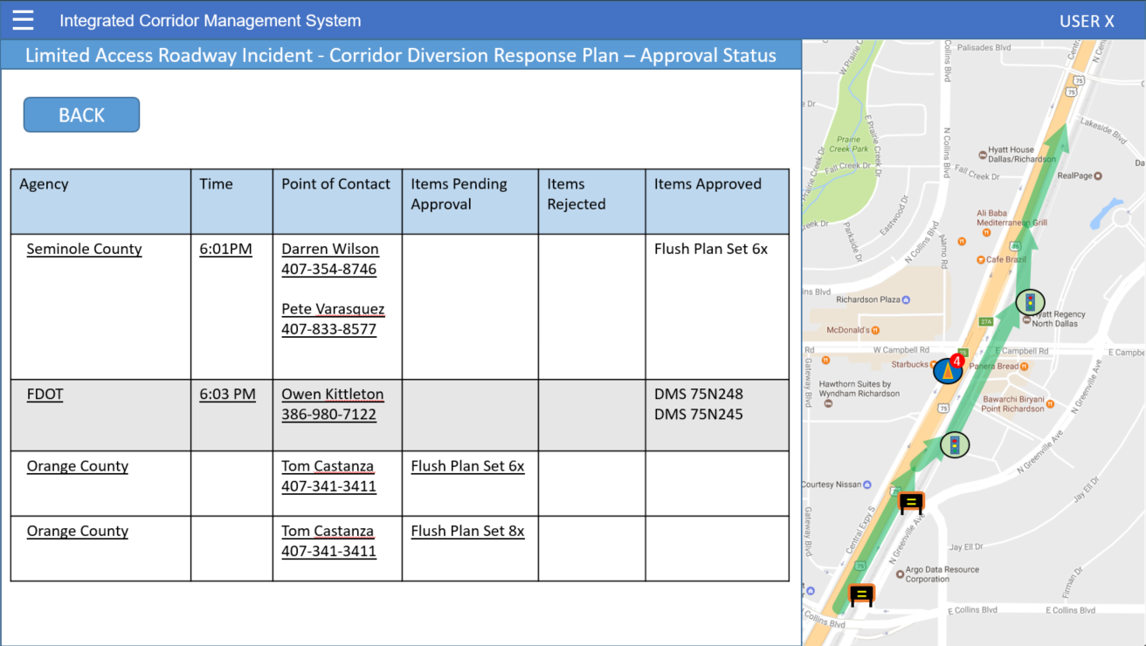

Figure 11: R-ICMS GUI – Response Plan Approval Status

### R-ICMS Sends Response Plan to SunGuide

If all the agencies approve, R-ICMS sends the R-ICMS response plan to the SunGuide software for further event management and activation. SunGuide software will receive the R-ICMS response plan recommendation and will respond to the request and provide updates back to the R-ICMS so that the R-ICMS can monitor the status of the R-ICMS response plan.

### SunGuide Operator Alert

SunGuide will process the R-ICMS response plan recommendation from R-ICMS. An alert will appear for the SunGuide operator that includes the R-ICMS response plan details. The SunGuide operator can review and incorporate the R-ICMS response plan into their SunGuide EM event or create a new event. The SunGuide operator can also reject the R-ICMS response plan recommendation, and add a comment as to why the R-ICMS response plan is being rejected.

R-ICMS response plan recommendations will have an R-ICMS response plan ID and SunGuide EM events will have an EM Event ID. These IDs will be shared between both systems so that both systems can keep track of R-ICMS response plan, SunGuide EM events, and which of them are associated. R-ICMS will use the event ID to monitor the associated event, and SunGuide will use the EM Event ID and the R-ICMS ID later when receiving recommendations from R-ICMS for updating and terminating R-ICMS response plans.

R-ICMS will send the location associated with the R-ICMS response plan with a recommendation. This location will be based on a directional roadway segment between entrance ramps. SunGuide will consider this location and present it to the operator, but the operator will fine tune the location based on the locations preconfigured as part of EM Event Management.

### SunGuide Event Response Plan

SunGuide software will allow the operator to review the new or amended SunGuide EM event response plan. Figure 12 shows the current EM event response plan dialog. The response plan dialog will allow the user to view the existing EM event response plan and review the recommended amendments from the R-ICMS response plan recommendation. The SunGuide operator will then be able to amend the response plan with the R-ICMS diversion route response plan elements into the non-activated, amended, SunGuide response plan. The user will then review the resultant SunGuide EM event response plan and modify it in the following ways:

* add, modify, and delete message content on DMS, HAR, CV TIMs, and email.
  + Some DMSes will need their content merged. For example, the original crash message, travel time message, and the newly recommended detour message may need to be placed on the same DMS sign. The current policy allows a maximum of two phases on the sign, so the operator will have to make the final determination of what gets put on those 2 available phases.
* include or exclude diversion route response plan elements:
  + Florida’s 511 system existing incident information notification
  + Existing capability will be preserved to add or remove existing Signals in SunGuide pre-configured diversion routes, leaving this capability unaffected. A configuration value will be added to the system to disable this existing capability if only using the R-ICMS response plan recommendations.
  + New capability to add or remove the entire set of route timing plans from the R-ICMS response plan recommendation. However, the operator will not be able to add, remove, or modify a subset of the set of route timing plans within the response plan element. This is due to the R-ICMS already coordinating the set of traffic signal controller timing plan selection changes with the maintaining agencies. Any change within the transportation system to the selected traffic signal controller timing plans may need to be coordinated with the agencies, and should be made in the R-ICMS system and resent to the SunGuide software as a modified R-ICMS response plan recommendation.
* modify DMS messages from the R-ICMS response plan and other DMS messages already in the SunGuide EM event response plan and/or already on the sign.

After review, the SunGuide operator will then activate the response plan invoking SunGuide to take actions to implement the elements of the resultant SunGuide response plan.

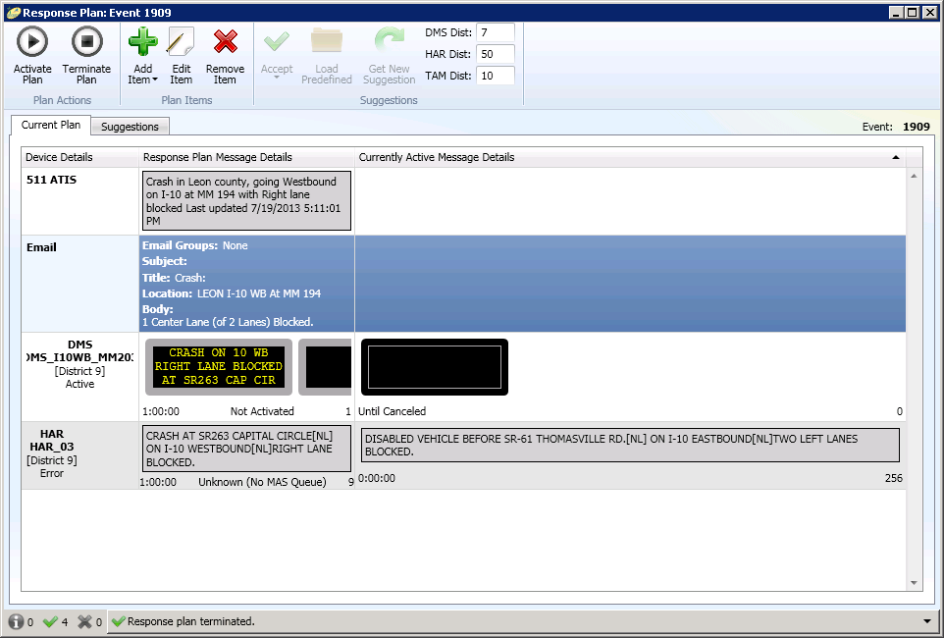

Figure 12: SunGuide GUI – SunGuide Response Plan Dialog

### Activate Flush Route Timing Plans

Upon activation of the response plan, SunGuide will activate a route timing plan. The protocol between each of the traffic signal ATMS systems will need to be defined, and will need to include the ability for the SunGuide software to pull configuration information (including traffic signal timing plan definitions) and status information on a real-time basis, and for the SunGuide software to issue commands that will activate a route timing plan.

### Event Life-Cycle

R-ICMS will continually monitor the event conditions and make changes to the R-ICMS response plan. After conditions change or return to normal, R-ICMS will make additional modified R-ICMS response plan recommendations, and finally make a recommendation to return to the traffic signal ATMS’s normal operations mode. R-ICMS will include R-ICMS recommendation IDs and SunGuide EM event IDs with its recommendation so that SunGuide knows which previous R-ICMS response plan recommendation is being replaced or terminated and to which SunGuide event this recommendation update or termination is being associated. These recommendations will also be presented to the operator and go through the process to recommend to the user to modify or remove the route timing plan element from the SunGuide EM event response plan. When a changed route timing plan is incorporated into the SunGuide EM response plan and activated, the changed route timing plan will be sent out to the traffic signal ATMS. When this change involves terminating the route timing plan, the SunGuide software will send the command to the traffic signal ATMS to return to the normal traffic signal operations *mode* just as if SunGuide had not sent any commands to the traffic signal ATMS at all. The normal traffic signal operations *mode* is not a specific route response *plan*, but an operational *mode* that is typically based on a time of day schedule of AM peak, PM peak, and off-peak coordinated traffic signal controller plans that are orchestrated by the traffic signal ATMS software.

After a configurable *route response plan timeout interval*, the route response plan will *timeout*, whereby the traffic signal ATMS will return to its normal traffic signal operations mode. For this reason, the SunGuide operator must reactivate the EM Event response plan within this timeout interval even if there is no change to the response plan needed or recommended by R-ICMS. This is a failsafe mechanism to prevent a diversion route timing plan from being in affect for a prolonged amount of time. This scenario may occur during a systems or communications failure preventing SunGuide software from sending the termination command. However, prior to the *timeout*, the traffic signal ATMS shall not activate a different route timing plan or signal controller timing plan that overrides one of the traffic signal controllers affected by the response plan invoked by the SunGuide software. Finally, when the SunGuide software terminates its route timing plan or it times out, the traffic signal ATMS software shall immediately invoke the route timing plans or signal controller timing plans that should be activate per the traffic signal normal operations mode.

### Other Related Operations and Features

#### Performance Monitoring

Performance Monitoring is an important offline operation to verify the correctness and efficiency of any operations. R-ICMS operations needs to be able to review events and SunGuide operator actions related to R-ICMS recommended response plans. The following questions should be answered by the reports generated from SunGuide:

* How many R-ICMS response plan recommendations were made for distinct R-ICMS events?
  + This could give us a global metric to know if the R-ICMS system is making recommendations or if there is an issue with R-ICMS’s ability to produce response plans
* How many R-ICMS response plan recommendations were made in total and broken down by new recommendations, updated recommendations, and terminations?
  + This could give us further detail on recommendations made, and if each recommendation is followed by updates and terminations, or if there’s an issue with the follow-up of updates and terminations.
* How many SunGuide EM events were associated with R-ICMS response plans
  + Broken down by event severity
    - This should also include the percentage of events that are eligible for an R-ICMS response plan recommendation. This is defined in R-ICMS by location between limited access highway entrance ramps. SunGuide might be able to associate SunGuide route timing plans with EM locations and use that for an approximation for event eligibility.
    - This could tell us which events by severity are making use of the R-ICMS response plans and by what percentage (of the eligible events, not of total events – i.e. not considering events without SunGuide route response plans or R-ICMS response plans defined – which should be the same thing).
  + Broken down by response plan action taken
    - This should also include the R-ICMS response plan recommendations that were dismissed as a category.
    - This could tell us what operator actions are taken, and might indicate if operators are able to effectively use the R-ICMS recommendations in the response plans or if the EM Event response plan and the R-ICMS response plans recommended need to be further investigated and fine-tuned.
  + Broken down by SunGuide operator taking action upon the R-ICMS response plan recommendation
    - This could tell us which operator may not be making use of the R-ICMS and point out something they are seeing that needs to be investigated, or may point out that additional training is needed.
* Event related reports with added filter for only including events with an R-ICMS recommendation
  + This report will allow further investigation on what transpired in the SunGuide event and at what timestamps for a detailed analysis spanning the widest variety of purposes.

All of these reports should be bounded by a user selectable date and time period. This date and time period should be further customizable by a pattern that allows to filter the period to a specific set of days of the week, hours of the day, and whether or not to exclude holidays.

Together, these reports should provide valuable insight into how well the R-ICMS was used in traffic operations, and quantify which portions or actions may need to be further investigated.

These metrics can show where R-ICMS or SunGuide can be further investigated and fine-tuned for improvement as the reported metrics can be compared across time periods.

## System Support

* This SunGuide software enhancement would be supported via the existing SunGuide software support contract managed by FDOT Central Office.
* The R-ICMS system will be developed and supported under a separate contract.
* The traffic signal controller ATMS and traffic signal controllers would be supported by the maintaining agencies.

## Support Environment

The R-ICMS system will be hosted by equipment residing in the regional transportation management center (RTMC). The R-ICMS hardware and software will be supported under contract with the software vendor with enforceable level of service that includes a 99% uptime, 15 minute response time and 1 hour repair time during normal business hours of 6 AM – 7PM on weekdays, and a 1 hour response time and a 4 hour repair time outside of normal business hours.

# Operational Scenario

Derek is driving from Tallahassee to Deland to deliver his home-brewed beer to Tushar and Clay and is caught in rush hour traffic on I-4 Northbound near the rest area almost at the end of his journey. It is stop and go traffic already; tensions are flaring and road rage abounds.

An unnamed ITS consultant is angrily tailgating trying to get there to crash the party, and swerves into the left lane to avoid stopping behind traffic ahead of him in his lane. He ends up behind Derek, just before Derek’s lane stops. The consultant reads a text message and doesn’t see the sudden stop ahead of him and rear ends Derek, causing the tailgate to open and the case of home-brew that was stored in the back of the truck to spill onto the road. Luckily, 1 of the 3 cases were in the cab, so it was not a total loss.

Luckily no-one was hurt, but FHP closes the roadway due to potential hazardous material because they were not familiar with home-brewing and to them the bottles and liquid on the roadway looked sketchy.

Back at the RTMC Eddie is ready to head out to his soccer game, but notices the congestion suddenly gets worse. He looks at the camera to see and confirm the incident, and creates a SunGuide EM event, a SunGuide EM event response plan, activates it, and dispatches a responder with chemical spill cleanup capabilities to the scene.

R-ICMS receives the event with the location and lane closure from the SunGuide databus, and generates an R-ICMS recommendation. Eddie’s phone buzzes and he already knows what that means – he just got an app alert notifying him that there’s a new R-ICMS response plan recommendation he needs to review. Eddie rolls his chair over to the next computer screen showing the R-ICMS response plan. He reviews it, approves it, and pulls up the screen for agency approval to monitor the status of the approvals.

Charlie is the agency traffic engineer but is already on the golf course. He was in mid-swing and heard his phone buzz back in the golf cart. He should have been able to open the alert showing the R-ICMS mobile app and be presented with the event details and the R-ICMS response plan recommendation for his review and approval. However, he was so angry that the distraction caused him to entirely miss the ball on his shot, that he throws his phone in the pond. Luckily, he had configured his agency approval profile in the R-ICMS system to automatically approve R-ICMS response plans if he was unable to response in 10 minutes.

Meanwhile, Eddie is pacing the RTMC floor, eager to receive the approval from Charlie as the only maintaining agency approval needed for this R-ICMS response plan containing a short diversion route all within Seminole County. Ten minutes feel like an eternity, but finally the auto-approval occurs and the R-ICMS response plan recommendation is sent to SunGuide.

SunGuide produces the alert and Eddie is all over it. He amends his SunGuide EM event response plan, activates it, and watches the status of the activation as the response plan screen shows if the command to the device was successful. Eddie captures the screenshot to send to Big D for their ICM operations presentation he will be giving to a technical session at Transpo 2020.

Once the road ranger assists with the cleanup, Derek gives the road ranger a beer to enjoy at home, and all vehicles go on their way. Traffic is still bad, so it takes about 20 minutes for the R-ICMS to recommend the termination of the R-ICMS response plan to SunGuide. Eddie reviews in SunGuide, amends the SunGuide EM event response plan with the recommendation which removes the corridor timing plan, and activates it. SunGuide sends a return to normal operations command to the traffic signal ATMS.

Throughout the event, Eddie noticed that a similar lane blockage in the past typically caused a much longer backup on I-4. He runs the performance reports to backup his hypothesis with data, and sends to Dale to include with his presentation. Eddie then no longer has time to go home first and luckily brought his uniform with him to work, and rushes directly to his soccer game and changes in the car upon arrival.

Derek arrives to Deland just in time for Tushar and Clay to hang out for a few minutes and discuss the success of the R-ICMS over a delicious home-brew.

# Summary of Impacts

* Increased operator responsibility
  + Additional response plan items to review, monitor, control
  + Additional coordination with local maintaining agencies
* Increased coordination between FDOT and local maintaining agencies
  + including establishing memorandum of understanding (MOU)
  + developing diversion routes
* Reduced delay and faster recovery from freeway incidents by allowing higher volume of traffic along diversion route

# Notes

## Deferred Items

The following items are important to be developed, but are deferred to the design and requirements phase:

1. **SunGuide Operator Alert Presentation:** Detailed requirements and design of how the R-ICMS response plan recommendation will be presented to the operator.
2. **EM Event Response Plan Review Screen Presentation:** Detailed requirements and design of how an R-ICMS response plan recommendation will be presented to the operator, and how the operator will interact with the GUI to review the recommendation alongside of the existing EM Event response plan (for existing events already having a response), and all of the other related detailed scenarios to ensure smooth operations for each of those scenarios.
   * Additional consideration should include:
     + The atomicity of the elements of an R-ICMS response plan, such as individual DMS messages.
     + Multiple life-cycle scenarios:
       1. new R-ICMS response plans and creating new events,
       2. new R-ICMS response plans associating to existing events
       3. updated R-ICMS response plans and existing events
       4. terminated R-ICMS response plans and existing events
       5. updated/terminated R-ICMS response plans with already terminated events
       6. possible to include all combinations of new/existing/terminating R-ICMS response plans with new/existing/closed events
     + Intuitive user controls and behavior including
       1. the ability to group a set of DMS signs and modify them as a temporary group to be removed or edited
       2. presenting information in columns off to the right that may be relevant enough, so the operator doesn’t have to leave the screen to reference the information in other dialogs.
3. **Traffic Signal ATMS Interface Requirements and Specification** for the three traffic signal controller ATMS software products.
   * Requirements are being kept in a spreadsheet for the entire intersection, and after analysis is done, they can be extracted from the spreadsheet and provided to signal ATMS vendors to discuss and coordinate the interface changes.
   * Each system may then have slightly different implementation details that should be specified and provide to the Department as a reference material to the SunGuide R-ICMS integration requirements and used for implementation.
   * An important nuance is how the system will be controlled to return to normal operations, which is typically some type of automatic mode based on a time of day schedule
4. Interface requirements and specification for SunGuide to be used by R-ICMS
5. A later enhancement may be to analyze what are some common reasons why an R-ICMS response plan recommendation is being rejected by the SunGuide operators and then provide a means to select the reason rather than manually typing it in. This would make it more efficient for operations and for later analysis, and can be a later enhancement. However, it would also need to considered if operators might just be select the first option to get past the prompt rather than actually providing specific feedback, so this would have also be taken into consideration.
6. A later enhancement to include Lane Control for part time shoulder use as an EM Event Response plan element type and incorporating it from an R-ICMS Response Plan recommendation could be considered in the future.
7. A later enhancement to include ramp meter metering rate changes as an EM Event Response plan element type and incorporating it from an R-ICMS Response Plan recommendation could be considered in the future.