ProjectName
Installation and Deployment Guide
Software Version: #

XXX 0, 0000

Installation and Deployment Guide template information
This section is provided to give information on this version of the document template. After inspection, delete this template information section from your final document.
The purpose of this document is to provide the System Administrator or any other technical stakeholder with a complete and easy to customize template designed specifically for the Technical Domain. It is intended to provide installation instructions to any stakeholder that has an interest or a role in the project.
How to use this template
This template is composed of a main structure that contains a brief description of each section plus a sample from an existing project.
This document contains comments to the author with guidelines on using or revising the document. These are included throughout in blue and italic. These instructions should be deleted from the finalized document.
This template contains example text to illustrate the type of information that goes in each section. Be careful to remove the samples that do not apply to your project.
Templates are prepared with line numbers turned on and the (DRAFT) designation in the footers. In the final copy to be signed, line numbers should be turned off and the (DRAFT) removed.
Document Responsibilities
The Installation and Deployment Guide is first created in the Deployment process step. Responsibilities for document creation and content are shown in the RACI chart below:
Group Manager | Project Manager | Technical Lead | Business Analyst | Developer | Testing Analyst
I | A | R | I | C | I

This template can be customized to meet the project’s needs and size; therefore sections can be added, removed or modified.
Combining or splitting documents
Documentation required by the process may be physically combined into fewer documents or split up into more documents in any way which makes sense to the project provided that all topics required by all the standard templates are present.
If information is split across several documents, all related documents shall be included in the reviews and sign off. For example, when installation and deployment instructions are in separate documents, the documents shall undergo the same preparation, review, and approval activities as well as review to ensure consistency of technical information among the component documents.
Reviews
The Installation and Deployment Guide is to be reviewed by the Technical Lead, and the Test Lead. At a minimum the review should ensure that the Installation and Deployment Guide is technically correct and can be used to install and deploy the software or system in the target environment, resulting in a working and usable system.
Approvals/Signoffs
The Installation and Deployment Guide is usually a deliverable component of the software solution. It is reviewed and bugs may be logged against it. But it is not approved or signed off unless required by the client scope/contract.

Installation Guide guidelines
Retain the following information in the final document, usually on the back of the cover page. The comment is for guidance and may be deleted or hidden.
Acknowledgements
This document may refer to documents in Adobe® Acrobat® Portable Document Format (PDF). (Adobe® and Acrobat® are registered trademarks of Adobe Systems Incorporated.)
This document may refer to use of products in the Microsoft® Office suite, the Microsoft® Team Foundation Server® and Visual Studio®. (Microsoft®, Team Foundation Server® and Visual
Guidelines for revising this document
This document is prepared using Microsoft Word. The Arial 11 point font is used.
Features of Word can be used to automatically maintain section numbers, table and figure numbers, and fields for information that appears frequently throughout the document.
This document is set up with margins of 0.75 inches on all sides. This setting will allow the document to be printed on both US Letter and European A4 paper sizes without reformatting.
This document contains comments to the author with guidelines on using or revising the document. To view this information, turn on the Review features of Word to show the Final Showing Markup view.
In this paragraph, fields are set for the organization name, ORGNAME (for example, FDOT), the organization acronym, the group name, GRPNAME (in this case, Applied Technologies Group), the group acronym, GRPINIT, and the project or product name, PROJ (for example, Automated Debris Management System), project initials, PROJINIT and product release, REL (for example 1.0.00). All occurrences of these strings in this document should be inserted as fields. These are currently set toFDOTApplied Technologies GroupATGProjectNameprojacronymrel FDOT, Applied Technologies Group, (ATG), ProjectName, projacronym and rel.
Ownership and revision
This Installation and Deployment Guide is owned and controlled by the project’s System Administrator. After a baseline of this document is published, the Technical Lead shall ensure that it is placed under change control.
Each change or revision made to this Installation Guide Document shall be summarized in “Revision history” section of this document.

Contents
Installation Guide information ii
Installation Guide guidelines iii
Contents iii
1 Introduction 1-3
1.1 Purpose 1-3
1.2 Revision history 1-3
1.3 Signoffs Error! Bookmark not defined.
1.4 Intended audience and reading suggestions 1-3
1.5 Technical project stakeholders 1-3
1.6 References 1-3
1.7 Definitions, acronyms and abbreviations 1-3
2 Server Configurations 2-3
2.1 Server 1 (Database) 2-3
2.1.1 Roles, Features, and Packages 2-3
2.1.2 Configuration 2-3
2.1.3 Configured Values 2-3
2.2 Server 2 (Web Application) 2-3
2.2.1 Roles, Features, and Packages 2-3
2.2.2 Configured Values 2-3
3 Software Installation 3-3
3.1 Server 1 (Database) 3-3
3.1.1 Prerequisites 3-3
3.1.2 Installation Steps 3-3
3.1.3 Configured Values 3-3
3.2 Server 2 (Web Application) 3-3
3.2.1 Prerequisites 3-3
3.2.2 Installation Steps 3-3
3.2.3 Configured Values 3-3
4 Testing the Installation 4-3
5 Troubleshooting 5-3

Introduction

Purpose
The purpose of this Installation and Deployment Guide is to describe in technical terms the steps necessary to install the software and make it operational.

Revision history
The Revision history table shows the date, changes, and authors who have worked on this document.
Version/Change request number | Version date | Description of changes | Author
 | 12/23/2011 | First Draft

Intended audience and reading suggestions
This Installation and Deployment Guide is intended to be used by technical stakeholders of the project who will be responsible for planning, performing, or maintaining the installation or deployment, such as the Systems Administrator, Chief Information Officer (CIO), Analysts, or Developers.
It is intended that stakeholders and software support personnel can read this document and coordinate their efforts in the installation/deployment of the application.

Technical project stakeholders
This section provides a list of all known stakeholders with an interest in the project.
Name | E-mail address | Phone | Role
 |  |  | Lead Developer
 |  |  | Systems Administrator

References
Replace the samples below with relevant references for the installation environment.
Reference No. | Document | Author(s)
REF-1 | Download WCF RIA Services Toolkit May 2010 | Microsoft
REF-2 | How to: Install SQL Server 2008 R2 (Setup) | Microsoft
REF-3 | Microsoft .NET Framework 4 (Standalone Installer) | Microsoft

Definitions, acronyms and abbreviations
Term | Definition
Administrator | This is anyone from the client that has been given administrative rights in the ProjectName.
IIS 7 | Microsoft Internet Information Server 7

Server Configurations
Replace the examples in this section with similar information about the server configurations required to provide the application environment.

Server 1 (Database)
Installation of this product is supported on the following operation systems and versions:
- Windows Server 2008 x64 R2
- Windows Server 2008 x64
- Windows Server 2008 x86 R2
- Windows Server 2008 x86
- Windows Server 2003 x64
- Windows Server 2003 x86

Roles, Features, and Packages
Packages
The following software packages must be installed on the operating system prior to installation of the software:
- Microsoft SQL Server 2008 R2 (see REF-2)
  - Database Engine
  - Connectivity Components
  - Management Tools

Configuration
SQL Server Configuration:
Authentication
Mixed mode authentication should be enabled
SQL Server Network Configuration
TCP/IP should be enabled
Named Pipes should be enabled
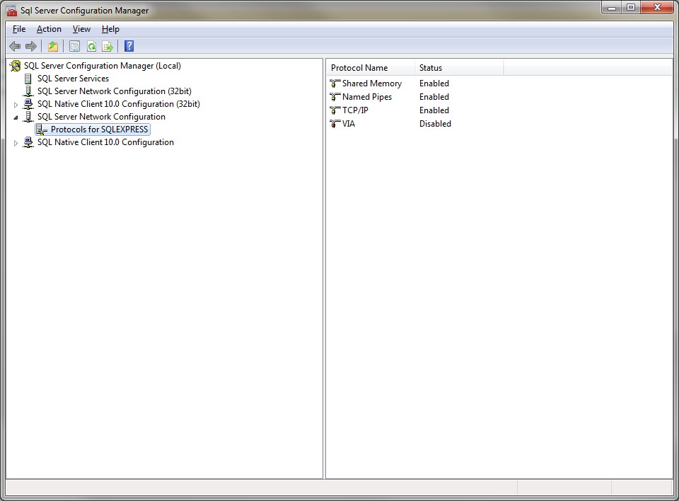

Configured Values
Use the table below to make note of the values for your installation environment for future reference. (Note: recording of information throughout should be in keeping with your local policies for system documentation and password security).
Information | Value
Server name
SQL instance name
SQL Server Administrator account name
SQL Server Administrator account password

Server 2 (Web Application)
Replace the examples in this section with similar information about the server configurations required to provide the application environment.
Installation of this product is supported on the following operation systems and versions:
- Windows Server 2008 x64 R2
- Windows Server 2008 x64
- Windows Server 2008 x86 R2
- Windows Server 2008 x86
- Windows Server 2003 x64
- Windows Server 2003 x86

Roles, Features, and Packages
Roles
The following server roles must be enabled on the operating system prior to installation of the software:
- Web Server (IIS)
Packages
The following software packages must be installed on the operating system prior to installation of the software:
- Microsoft .NET Framework 4.0 Standalone Installer (see REF-3)
- Microsoft WCF RIA Services Toolkit May 2010 (see REF-1)

Configured Values
Use the table below to make note of the values for your installation environment for future reference.
Information | Value
Server Name

Software Installation
Replace the examples in this section with step by step instructions about the software installation or deployment.

Server 1 (Database)

Prerequisites
- All steps in section 2 “Server Configurations” have been performed.

Installation Steps
- Open SQL Server Management Studio and log into the server and instance using the account name and password you noted in section 2.1.3.
- Create a new database catalog named “database”
- Create a new user configured for SQL Authentication named “authentication_owner” and note the password in section 3.1.3.
- Update the user mapping for the user created in step 3 to add the database role membership “db_owner” for the catalog created in step 2.
- Restore the backup for the “database” catalog with the following options:
  - Overwrite the existing database
  - Leave the database ready to use by rolling back uncommitted transactions. Additional transaction logs cannot be restored (RESTORE WITH RECOVERY)
- Run the following script against the catalog configured in step 2:
- sp_change_users_login ‘update_one’, ‘authentication_owner’, ‘authentication2_owner’
- Create a new database catalog named “applicationProviders”
- Create a new user configured for SQL Authentication named “applicationproviders_owner” and note the password in section 3.1.3.
- Update the user mapping for the user created in step 8 to add the following database role memberships for the catalog created in step 7:
  - aspnet_Membership_BasicAccess
  - aspnet_Membership_FullAccess
  - aspnet_Membership_ReportingAccess
  - aspnet_Personalization_BasicAccess
  - aspnet_Personalization_FullAccess
  - aspnet_Personalization_ReportingAccess
  - aspnet_Profile_BasicAccess
  - aspnet_Profile_FullAccess
  - aspnet_Profile_ReportingAccess
  - aspnet_Roles_BasicAccess
  - aspnet_Roles_FullAccess
  - aspnet_Roles_ReportingAccess
  - aspnet_WebEvent_FullAccess
  - db_owner
- Restore the backup for the “applicationProviders” catalog with the following options:
  - Overwrite the existing database
  - Leave the database ready to use by rolling back uncommitted transactions. Additional transaction logs cannot be restored (RESTORE WITH RECOVERY)
- Run the following script against the catalog configured in step 7:
- sp_change_users_login ‘update_one’, ‘applicationproviders_owner’, ‘applicationproviders_owner’
- If you have not already doen so, determine who will be the initial Administrator of the application with the ability to add and remove users and note the domain and account using all lowercase characters in section 3.1.3.
- If the user from step 12 has not already been added, make the following edits to the catalog you created in step 12 to configure the initial Administrator:
  - Add a new record to the dbo.aspnet_Users table:
    - ApplicationId: anaanann-naaa-naaa-nana-nnabannnanna
    - User ID: [null]
    - UserName: [Initial Application Administrator Domain Account Name (domain\account) from section 3.1.3]
    - LoweredUserName [Initial Application Administrator Domain Account Name (domain\account) from section 3.1.3]
    - MobileAlias: [null]
    - IsAnonymous: False
    - LastActivityDate: [Today]
  - Note the GUID that is created for the UserId field when the record is applied to the dbo.aspnet_Users table in section 3.1.3
  - Add a new record to the dbo.aspnet_UsersInRoles table:
    - UserId: [dbo.aspnet_Users UserId from section 3.1.3]
    - RoleId: anaanann-naaa-naaa-nana-nnabannnanna
  - Add a new record to the dbo.aspnet_UsersInRoles table:
    - UserId: [dbo.aspnet_Users UserId from section 3.1.3]
    - RoleId: anaanann-naaa-naaa-nana-nnabannnanna
  - Add a new record to the dbo.aspnet_UsersInRoles table:
    - UserId: [dbo.aspnet_Users UserId from section 3.1.3]
    - RoleId: anaanann-naaa-naaa-nana-nnabannnanna
  - Add a new record to the dbo.aspnet_Membership table:
    - ApplicationId: anaanann-naaa-naaa-nana-nnabannnanna
    - UserId: [dbo.aspnet_Users UserId from section 3.1.3]
    - Password: 1234
    - PasswordFormat: 0
    - PasswordSalt: 1234
    - MobilePIN: [null]
    - Email: [null]
    - LoweredEmail: [null]
    - PasswordQuestion: [null]
    - PasswordAnswer: [null]
    - IsApproved: True
    - IsLockedOut: False
    - CreateDate: [Today]
    - LastLoginDate: [Today]
    - LastPasswordChangedDate: [Today]
    - LastLockoutDate: [Today]
    - FailedPasswordAttemptCount: 0
    - FailedPasswordAttemptWindowStart: [Today]
    - FailedPasswordAnswerAttemptCount: 0
    - FailedPasswordAnswerAttemptWindowStart: [Today]
    - Comment: [null]

Configured Values
Use the table below to make note of the values for your installation environment for future reference.
Information | Value
Initial application administrator domain account name (domain\account)
dbo.aspnet_Users UserId
application_owner account password
applicationproviders_owner account password

Server 2 (Web Application)
Replace the examples in this section with step by step instructions about the web application installation or deployment.

Prerequisites
- All steps in section 2 “Server Configurations” have been performed.
- All steps in section 3.1 “Software Installation, Server 1 (Database)” have been performed.

Installation Steps
- Contact your SharePoint administrator and note the following in section 3.2.3:
  - SharePoint URL
  - SharePoint dashboard access domain
  - SharePoint dashboard access user name
  - SharePoint dashboard access password
- Contact your ArcGIS administrator and note the following in section 3.2.3:
  - XYZ map layer service URL
  - ABC map layer service URL
- Log in as a server administrator.
- Create a folder to house the web application files and note the location in the Physical path field in section 3.2.3.
- Copy deployment files to the folder you created in step 2.
- Open the IIS Manager console Snap-In.
- The application should be assigned an application pool separate from other web applications running on the server. The steps to create the application pool are:
- Right-click “Application Pools” in the Internet Information Services (IIS) Manager Snap-In and choose “Add Application Pool”
- Configure the following values in the Add Application Pool dialog:
  - Name: “SYSTEM AppPool”
  - .NET Framework Version: 4.0.30319
  - Managed pipeline mode: Integrated
  - Start application pool immediately: Checked
- The application should be assigned to the root of a new web application in IIS. The steps to create the web application are:
  - Right-click “Sites” and select “Add Web Site” from the context menu.
  - Configure the following values in the Add Application Pool dialog:
    - Site name: SYSTEM Dashboard
    - Application pool: SYSTEM Dashboard AppPool
    - Physical path: [Physical path noted in section 3.2.3]
    - Pass-through authentication: Application user (pass-through authentication)
    - Binding
      - Type: http
      - IP Address: [note IP in section 3.2.3 if static]
      - Port: 80
      - Host name: [enter host name and configure DNS for your environment, note host name in section 3.2.3]
      - Start Web site immediately: checked
  - Select Authentication for the web application you created in step 6 and enable Windows Authentication.
- Open Windows Explorer and navigate to the Physical path noted in section 3.2.3.
- Open the web.config file using a text editor (such as NotePad) and make the following edits:
  - AppSettings section:
    - SharePointUrl value: [SharePoint URL value from section 3.2.3]
    - XyzDynamicLayerUrl value: [AET map layer service URL value from section 3.2.3]
    - AbcDynamicLayerUrl value: [RTCS map layer service URL value from section 3.2.3]
    - SharePointAccessDomain value: [SharePoint dashboard access domain value from section 3.2.3]
    - SharePointAccessUserName value: [SharePoint dashboard access user name value from section 3.2.3]
    - SharePointAccessPassword value: [SharePoint dashboard access password value from section 3.2.3]
  - ConnectionStrings section:
    - Modify “connectionString” value for name “applicationBdmsEntities”
      - DataSource: [ [Server name]\[SQL instance name] from section 2.1.3]
      - Password: [application_owner account password from section 3.1.3]
    - Modify “connectionString” value for name “Provider”
      - DataSource: [ [Server name]\[SQL instance name] from section 2.1.3]
      - Password: [applicationproviders_owner account password from section 3.1.3]
- Open a command prompt and perform the following command:
  - iisreset
- Ensure you can access the web application using the host name you noted in section 3.2.3.
- Contact your SharePoint administrator to configure the Web Part Page Viewer to access the application via the SharePoint user interface.

Configured Values
Use the table below to make note of the values for your installation environment for future reference.
Information | Value
Physical path
IP Address (if static)
Host name
SharePoint URL
SharePoint dashboard access domain
SharePoint dashboard access user name
SharePoint dashboard access password
XYZ map layer service URL
ABC map layer service URL

Testing the Installation
- Navigate your web browser to the Host Name you noted in section 3.2.3.
- Ensure that the login prompt appears.

Troubleshooting
This section is optional. Here you can describe troubleshooting steps including log locations and other information that may assist an administrator and the development team in determining the root cause and resolution to any issues that arise.

RACI stands for: R – Responsible - "the doer - primary author"; A – Accountable - "the buck stops here" - reviews for completeness and correctness; C – Consulted - "stakeholder - invited to provide input"; I – Informed - "gets the information"

